**EXPERIMENT NO: 01**

**AIM: Prepare a detailed statement of problem for the selected/allotted mini project and identify suitable process model for the same with justification.**

**PROBLEM STATEMENT:**

The Internet is full of Malicious content which is irritating be it in the form of URL or SMS on the phones or emails. Rumors are the other form of content that can spread on the internet within seconds. All these methods are easy ways as cyber attacks on an individual. So this project will be able to identify all these problems by saying if they are spam or not and make it a safe user experience with preventing them from cyber attacks and stopping them from sending their important data.

**ABSTRACT:**

Short Message Service has been one of the finest communication modes considering the development in mobile communication systems. With the advancement in this technology, it's simple operation and low cost, has led to the usage of SMS. But this has brought in the problem of spam. So, it's necessary to identify these mobile attacks and keep personal data on phone secure. Same case will be for Emails. Detection of spam will help in blocking messages and filtering them. This Cyber Security System will involve Neural Networks and NLP. Collected dataset of spam messages will be pre-processed and classification methods will be applied.

**EXISTING SYSTEM:**

Most of the SMS & Email Spam detection available on the market either do one of the two things not both i.e. it either filters SMS or Email as spam or ham. The current systems lack some information such as edit format, header and Multi-purpose Internet Mail Exchanger (MIME), use of unstandardized abbreviation and acronyms and lastly, support for only textual representation. Spam filters have been deployed in either the client side (user mobile phone) or the server side (mobile network operators‟ side) or at both ends (client and server side approach).

**TECHNICAL FLOW:**

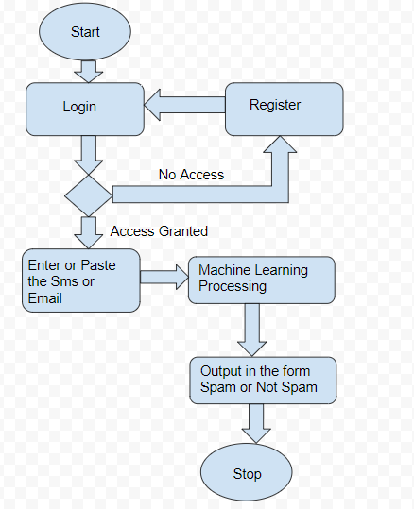

**Figure 1:Technical Flowchart for Spam Detection**

From the given flowchart it is very easy to understand the technical flow of the project. Starting the system with login wherein if you have registered with the service before you can proceed to homepage , if not you will have to register and then login. Once you land on the homepage you will have to enter the message or paste to message to check if they are spam or not. Messages can be Emails or Sms. Once the message is entered machine learning starts in the background. The machine learning model will then classify the message on the field as Spam or Ham(Normal message) by using classification techniques like Naive Bayes theorem or Decision Tree approach. Once the model predicts Spam or not , it will be displayed to the user.

**SOCIAL IMPACT:**

This project will be very useful in identifying what is malicious. For example, most cyber crimes start from a sms, Email or a phone call it. The message can be like “You have won a lottery of Rs. X amount. Please send us the bank account details to claim it” or “You have been chosen as a lucky person from shopping with your credit card in XYZ Store. Please provide us your Credit Card details with Card expiry date and CVV to claim your prize Limited Period Offer ” .So our system allows the user to check if a message received is a spam message or not. The model will have some errors but mostly will be accurate enough to identify the message as Spam or not. This can reduce a lot of cyber crimes happening.

**CONCLUSION:** We described our problem statement on our topic Spam SMS and Email Detection. We briefly studied the topic and gave a brief abstract on it. We discussed the existing system and how spam filters have been deployed. We also covered the social aspect of our topic. A technical flow i.e. flowchart of the working of our system is also made.